Bahria University,

Karachi Campus



LAB EXPERIMENT NO.

___06___

LIST OF TASKS

|  |  |
| --- | --- |
| TASK NO | OBJECTIVE |
| **01** | Create a function that calulates the power of 100 of a number entered as a parameter. |
| **02** | Write a javascript function that takes an array of numbers and a target number. The function should find two different numbers in the array that, when added together, give the target number. For example: answer([1,2,3], 4) should return [1,3]. |
| **03** | Write a javascript function and ask user to enter the age, this function aim to show a message that a person can drive, if the age is greater than or equal to 18 otherwise can’t drive, by using a ternary operator instead of the [if-else](https://www.javascripttutorial.net/javascript-if-else/) statement. |
| **04** | Using switch in javascript, write a program to create any four browsers cases of your choice and generate alert (“I am using xyz browser) if user select any one of them. |
| **05** | Write a javascript arrow function named calculateSupply that:Takes 2 arguments: age, amount per day.Calculates the amount consumed for rest of the life (based on a constant max age).Outputs the result to the screen like so: "You will need NN to last you until the ripe old age of X" |
| **06** | Create an object to hold information on your favorite recipe. It should have properties for title (a string), servings (a number), and ingredients (an array of strings). Write a method “Recipe” that print the separate lines (one console.log statement for each |
| **07** | Write a javascript program to get the below object to go from: |
| 08 | Design a Registration form using Bootstrap and validate it using Javascript |

Submitted On

23-11-2023

(Date: DD/MM/YY)

**Task 01:** Create a function that calulates the power of 100 of a number entered as a parameter.

**Solution:**

const calculate=(num, powerNumber) =>{

console.log("The power of 100 is "+Math.pow(num, powerNumber));}calculate(100,2)

**Output:**

**Task 02:** Write a javascript function that takes an array of numbers and a target number. The function should find two different numbers in the array that, when added together, give the target number. For example: answer([1,2,3], 4) should return [1,3].

**Solution:**

function findTwoNumbers(arr, target) {for (let i = 0; i < arr.length - 1; i++) {for (let j = i + 1; j < arr.length; j++) {if (arr[i] + arr[j] === target) {return [arr[i], arr[j]];}}}return null;}const result = findTwoNumbers([1, 2, 3], 4); console.log("The return value is "+result);

**Output:**

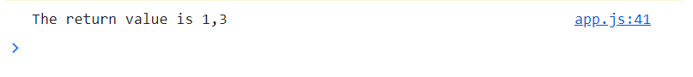

**Task 03:** Write a javascript function and ask user to enter the age, this function aim to show a message that a person can drive, if the age is greater than or equal to 18 otherwise can’t drive, by using a ternary operator instead of the [if-else](https://www.javascripttutorial.net/javascript-if-else/) statement.

**Solution:**

let age=+prompt("Enter the Age");let printMessage=age>=18?"You can Drive":"You cannot Drive"alert(printMessage)

Output:**

**Task 04:** Using switch in javascript, write a program to create any four browsers cases of your choice and generate alert (“I am using xyz browser) if user select any one of them.

**Solution:**

let browserName=prompt("Enter Browser Name");switch(browserName){case "chrome":alert("I am using "+browserName+ " browser");break;case "firefox":alert("I am using "+browserName+" browser");break;case "safari":alert("I am using "+browserName+" browser");break;case "edge":alert("I am using "+browserName+" browser");break;default:alert("Unknown browser");}

**Output:**

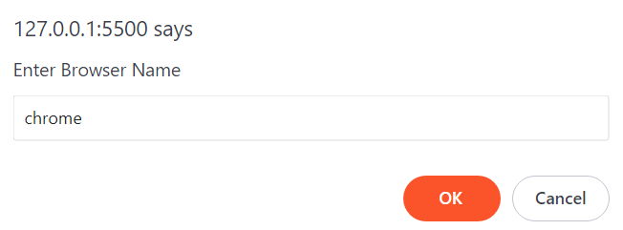

**Task 05:** Write a javascript arrow function named calculateSupply that:

* 1. takes 2 arguments: age, amount per day.
  2. calculates the amount consumed for rest of the life (based on a constant max age).
  3. outputs the result to the screen like so: "You will need NN to last you until the ripe old age of X"

**Solution:**

const maxAge=50;let calculateSupply=(age,amountPerDay)=>{if(age<maxAge){let remainingDay=(maxAge - age) * 365 * amountPerDay;alert("You will need "+ remainingDay+ " to last you until the ripe old age of "+maxAge)}}calculateSupply(25,1);

**Output:**

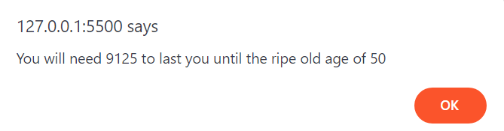

**Task 06:** Create an object to hold information on your favorite recipe. It should have properties for title (a string), servings (a number), and ingredients (an array of strings). Write a method “Recipe” that print the separate lines (one console.log statement for each), log the recipe information so it looks like:

Tea

Serves: 2

Ingredients:

Sugar

Tea

Water

Milk

**Solution:**

const favoriteRecipe = {title: 'Tea',servings: 2,ingredients: ['Sugar', 'Tea', 'Water', 'Milk'],printRecipe: function (){console.log(this.title);console.log(`Serves:${this.servings}`);console.log('Ingredients:');this.ingredients.forEach(ingredient => {console.log(ingredient);});}};favoriteRecipe.printRecipe();

**Output:**

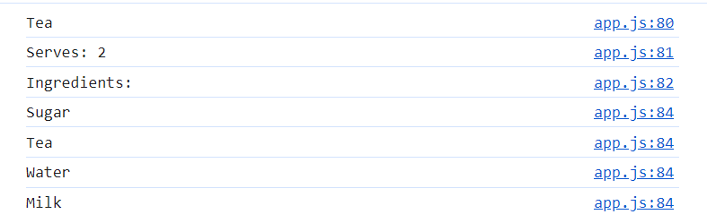

**Task 07:** Write a javascript program to get the below object to go from:

let obj = {my: 'name',is: 'Rudolf',the: 'raindeer'}// to this:'my name is Rudolf the raindeer'

**Solution:**

let obj = { my: 'name', is: 'Rudolf', the: 'raindeer'}console.log(`My name is ${obj.is} the ${obj.the}`);

**Output:**



**Task 08:** Design a Registration form using Bootstrap and validate it using Javascript

**Solution:**

(() => {'use strict'const forms = document.querySelectorAll('.needs-validation')Array.from(forms).forEach(form => {form.addEventListener('submit', event => {if (!form.checkValidity()) {event.preventDefault()event.stopPropagation()}form.classList.add('was-validated')}, false)})})()

**HTML:**

<h1>Registration Form</h1>

<form class="row g-3 needs-validation" novalidate><div><div class="col-md-4 has-validation"><label for="validationCustom01" class="form-label">Full Name</label><input type="text" class="form-control" id="validationCustom01" required><div class="invalid-feedback" id="verify-email">Please choose your valid email.</div></div></div> <br> <br><div><div class="col-md-4"><label for="validationCustomEmail" class="form-label">Email Address</label><div class="input-group has-validation"><span class="input-group-text" id="inputGroupPrepend">@</span><input type="email" class="form-control" id="validationCustomEmail" aria describedby="inputGroupPrepend" required><div class="invalid-feedback">Please choose your valid email.</div></div></div></div><div><div class="col-md-4 has-validation"><label for="validationCustomNumber" class="form-label">Phone(Enter only 10 digit Number)</label><input type="number" class="form-control" id="validationCustomNumber" value="023-123-099" required><div class="invalid-feedback">Please choose valid number.</div></div></div> <br><div><div class="col-md-4 has-validation"><label for="validationCustomPassword" class="form-label">Password</label><input type="password" class="form-control" id="validationCustomPassword" required><div class="invalid-feedback">Please write valid password.</div></div></div> <br><div><div class="col-md-4 has-validation"><label for="validationCustomConfirmPassword" class="form-label">Confirm Password</label><input type="password" class="form-control" id="validationCustomConfirmPassword" required><div class="invalid-feedback">Enter Password Confirmation</div></div></div> <br><div class="col-12"><button class="btn btn-primary" onclick="formSubmit()" type="submit">Submit form</button></div></form>

**Output:**

